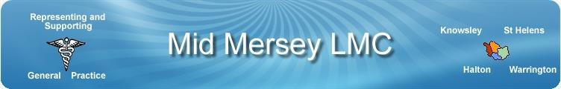

Representing and supporting GPs and Practices within Knowsley, Halton, St Helens and Warrington

What is an an LMC?
A Local Medical Committee (LMC) is an independent democratically elected professional representative body for local GPs, comprised of local GPs and representing the diverse interests which make up general practice. LMCs have been in existence since 1911 with statutory roles and responsibilities recognised by successive NHS Acts.

What is is Mid Mersey LMC?
The Mid Mersey LMC represents all GPs (Principals, Salaried, Sessional and Registrars) in the four Place areas of Knowsley, Halton, St Helens and Warrington. The LMC was created in April 2007 by the merger of two previous LMC organisations, North Cheshire and St Helens & Knowsley, as a result of changes in local Primary Care Trust boundaries at that time.
The Committee is made up from GPs from all of 4 Place areas across Mid Mersey and representatives from the GPC/BMA who are invited to observe the meetings that are held every 6 weeks.

Role of the LMC
The LMC exists to represent and support its constituent GPs. It is a professional representative body, not a trade union - the BMA being doctor’s trade union. The main responsibilities of the LMC have remained largely unchanged through successive NHS reorganisations, although the new contract in 2004 provided a number of new responsibilities involving enhanced services, QOF, practice contacts, contract review, dispute resolution, commissioning, premises etc.

LMC functions include:

Representation
We represent the views of GPs to a variety of bodies, most notably our local Place and NHS England Cheshire & Merseyside, Local Authorities, Social Services, NHS Trusts, other contractor professions, patient representative bodies, MPs as well as national bodies such as the General Practitioners Committee of the BMA (GPC), General Medical Council (GMC), the Royal College of General Practitioners (RCGP), local and national media.

The LMC serves as the link between local GPs and GP’s national negotiating body, the General Practitioners Committee (GPC) of the BMA. GPC policy decisions are guided and determined by the Annual Conference of LMCs at which the LMC is able to reflect local GPs’ concerns and aspirations.

Mid Mersey LMC is also represented at the BMA’s Annual Representatives Meeting where doctors from all disciplines of medicine meet to set BMA policy.

Advice
We keep our constituent GPs informed of local and national developments, circulating guidance on local issues and initiatives. We provide professional representation, guidance and support to our local GPs and Practices. Although we do not provide either legal or financial advice.

Pastoral
We provide advice or assistance to constituent GPs on Health-related issues, Personal crisis, Practice response to complaints, In house Practice dispute conciliation. The need for pastoral help may arise from a patient complaint, or an investigation, or as a result of the individual’s ill health.

How to access support
Self-referral can be made via the LMC office on 01744 28588
or email trish.gormley@mmlmc.org.uk

